BS 851

Homework 6&7

Irene Hsueh

**Class 6**

**Question 1**

H0: The proportion of death is the same in the low experimental dose and placebo groups.

HA: The proportion of death is not the same in the low experimental dose and placebo groups.

H0: The proportion of death is the same in the low experimental dose and placebo groups.

HA: The proportion of death is not the same in the low experimental dose and placebo groups.

2 tests will be performed, so the Bonferroni correction is $\frac{0.05}{2}=0.025$.

**Question 2**

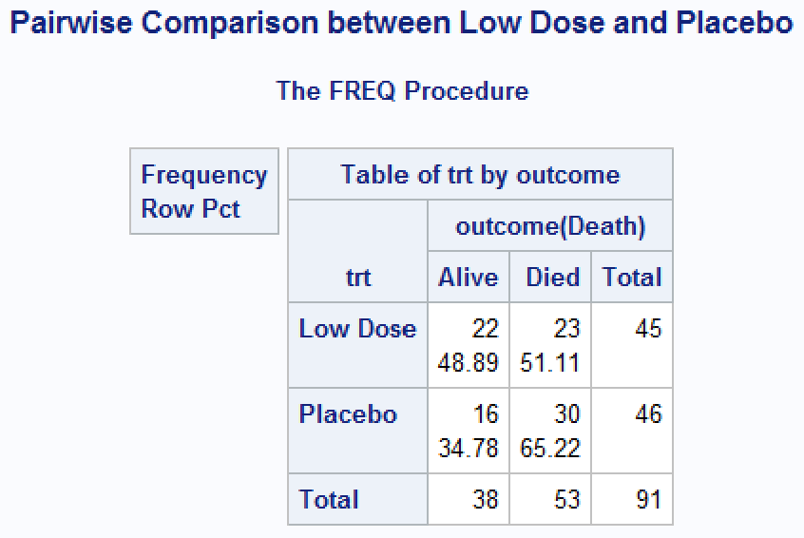

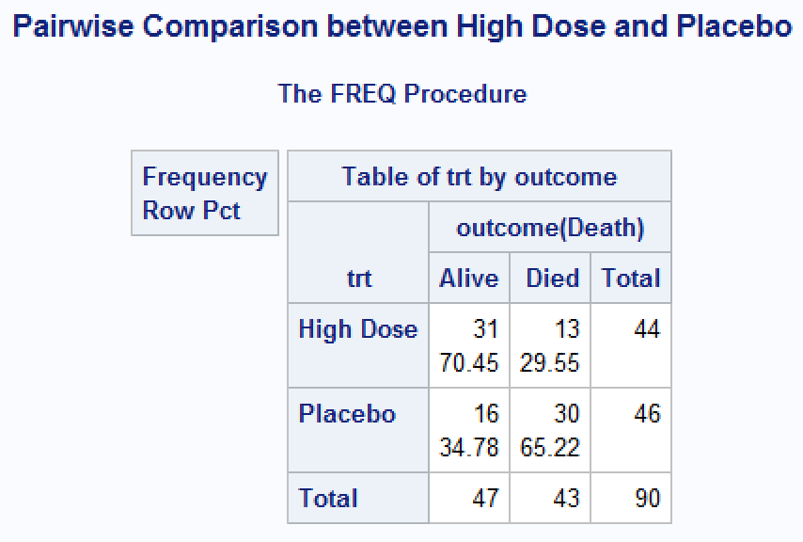

51.11% of subjects died in the low dose treatment group and 29.55% died in the high dose treatment group.

low dose vs placebo p-value = 0.1725

adjusted p-value = 2×0.1725 = 0.3454

high dose vs placebo p-value = 0.0007

adjusted p-value = 2×0.0007 = 0.0014

**Question 3**

There are 14.11% (95% CI: -37.06%, 8.84%,) fewer cases of death in the low dose group than in the placebo group. There are 35.67% (95% CI: -57.70%, -13.64%) fewer cases of death in the high dose group than in the placebo group.

**Question 4**

The risk of death in the low dose group is 78.36% (95% CI: 52.21%, 117.65%) of the risk in the placebo group. The risk of death in the high dose group is 45.30% (95% CI: 25.49%, 80.50%) of the risk in the placebo group.

**Question 5**

The low doses’ adjusted p-value was 0.3454, which is greater than the α=0.05 significance level, while the high dose’s adjusted p-value was 0.0014, which is less than the α=0.05 significance level. Only the null hypothesis of the proportion of death being the same as the placebo group can be rejected for the high dose comparison.

The low dose’s 95% confidence interval for the risk difference contains 0 and the risk ratio contains 1, so those effects were not significant. On the other hand, the high dose’s 95% confidence interval for the risk difference doesn’t contain 0 and the risk ratio doesn’t contain 1, so those effects are statistically significant.

Since at least one dose, the high dose, was found to be significantly more effective than the control at reducing mortality, the study was found to be a success.

**Question 6**

H0: The proportion of overdose is the same in the stigma intervention group and control group.

HA: The proportion of overdose is not the same in the stigma intervention group and control group.

The investigators are hoping to detect a 10% decrease in proportion of overdose in the stigma intervention group compared to the control group.

**Question 7**

$$\frac{282}{1-0.15}=332$$

A sample size of 282 total subjects, 141 per group, yields 80% power to detect a significant difference in proportion of overdoses of 10%, assuming risk of 15% in the control group and 5% in the stigma intervention group. To allow for 15% loss to follow-up, a total of 332 total subjects are needed.

**Question 8**

$$\frac{297}{1-0.15}=350$$

A sample size of 297 total subjects yields 80% power to detect a significant difference in proportion of overdoses of 10%, using a 2:1 allocation ratio while assuming risk of 15% in the control group and 5% in the stigma intervention group. To allow for 15% loss to follow-up, a total of 350 total subjects are needed.

**Question 9**

H0: The average change in stigma score from baseline to 12 months is the same in the stigma intervention group and control group.

HA: The average change in stigma score from baseline to 12 months is not the same in the stigma intervention group and control group.

Using a sample of 350 subjects in a 2:1 allocation ratio to detect a significant difference in change in stigma score from baseline to 12 months of at least 3 units, 90.8% power will be yielded.